# SSD

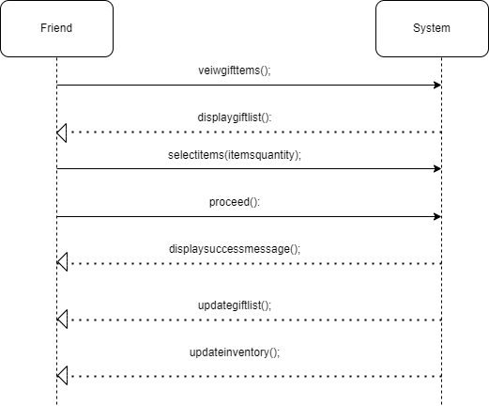

# Usecase

## View Event

**Use Case ID:** UC-07

**Use Case :** View Event

**Primary Actor:**

- Friend

**Secondary Actors:**

- System

**Stakeholders:**

- User(the person who has created the event)

- Shop Owner(the person in whose shop or site the event is registered)

**Preconditions:**

- Friend has an access to the good internet Internet connection.

- Event deadline has not reached yet.

- Friend is authorized for the gifts selection by the event creator.

**Main Flow:**

1. Friend goes through authorization process to access the event.

2. System shows event name, date, and description.

3. System displays items list created by user(event organizer) along with the price of item.

4. Friend clicks on each item to check their quantity required .

5. System fades the items that are fully selected and otherwise display the item details.

**Alternate Flow:**

1. Events deadline has reached during viewing.

2. Their can be traffic on event site causing errors.

3. Friend accidentally exit the website.

**Postconditions:**

- Friend can view event details , available or remaining items and their quantity.

**Inputs:**

Event id

User login id

**Outputs:**

List of available shop items (with names, descriptions, prices, quantities)

Stock availability confirmation

Details about the remaining required gift items.

### Select Gifts

**Use Case ID:** UC-08

**Use Case:** Select Gifts

**Primary Actor:**

Friend (Guest User)

**Secondary Actors:**

System

**Stakeholders:**

User (the person who created the event)

Shop Owner (the person providing the items in the shop)

**Preconditions:**

The friend has a stable internet connection.

The event is active and has not passed its deadline.

The friend has permission from the event creator to select gifts.

**Main Flow:**

The friend accesses the event registry through the system.

The system displays the event name, date, and details.

The system shows the list of available gifts for selection.

The friend chooses the gifts they wish to select.

The friend submits their gift selections.

The system confirms the gift selections and updates the registry accordingly.

**Alternate Flow:**

The event deadline has passed during the selection process.

The friend accidentally navigates away from the website.

**Postconditions:**

The friend can view the selected gifts and their status in the event registry.

**Inputs:**

Event ID

friend login ID

Selection_Id

List_Id

Item_Id

**Outputs:**

Confirmation message of selected gifts

Updated gift selection list reflecting the friend’s choices

Notification of available or unavailable gifts